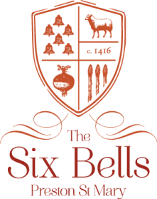

Sample a’la’carte March 2019

Starters
Soup of the day, crusty bread £5
Goats cheese and red onion tart £6
Pulled smoked ham hock, homemade piccalilli, apple £6
Classic prawn cocktail £6
Moules marinières - starter £7/ main with chips £14

Mains
Pie of the day, greens, chips, gravy £10.50
Suffolk ham, fried egg, hand cut chips £9.50
Adnams beer battered haddock and chips, mushy peas, tartare sauce £11.50
Smoked haddock fishcake, poached egg, capers, hollandaise £12
Chestnut mushroom, spinach and parsley tagliatelle £11.50
The Six Bells burger, smoked bacon, cheddar, homemade relish, salad, chips £12.50
Broadend Farm rump steak, chips, salad, roasted vine tomatoes, garlic butter £15
Add a sauce for £2.50 – mushroom, peppercorn, blue cheese, garlic butter

Sides £3
Hand cut chips / Garden salad / Onion rings
Buttered greens / Mixed vegetables

A discretionary fee of 12.5% will be added to the final bill of tables of 8 or more
All prices include VAT. Game dishes may contain shot

